**Apis Insight for Phenotype Classification and Hive Health Forecasting using IoT and Deep Learning**

A PROJECT REPORT

*Submitted by*

**RITVIK KUMAR SINGH [Reg No. RA2011003010228]**

**TANYA SINGH [Reg No: RA2011003010231]**

*Under the Guidance of*

**Dr. A. ARULMURUGAN**

Assistant Professor, Department of Computing Technologies

*in partial fulfillment of the requirements for the degree of*

**BACHELOR OF TECHNOLOGY**

**in**

**COMPUTER SCIENCE AND ENGINEERING**



**DEPARTMENT OF COMPUTING TECHNOLOGIES**

**COLLEGE OF ENGINEERING AND TECHNOLOGY**

**SRM INSTITUTE OF SCIENCE AND TECHNOLOGY KATTANKULATHUR– 603 203**

**MAY 2024**

**ABSTRACT**

This project features image recognition technology for individual bee health, subspecies identification, and pollen type prediction along with beehive assessment with live monitoring along with a user-friendly interface with distinct webpages for bee and beehive analyses along with real time monitoring for real-time analysis and instant feedback through integration of deep learning. This tool empowers beekeepers with tools for informed decision-making in hive management and contribute to bee conservation efforts, fostering biodiversity and meeting Sustainable Development Goals. The project comprises an advanced image analysis module that accurately assesses the health of individual bees and identifies subspecies based on uploaded images. Additionally, an image recognition system evaluates beehive health, enabling remote monitoring and proactive management. The integration of Arduino sensors offers real-time data on temperature and humidity conditions within beehives. A user-friendly web interface facilitates seamless interaction, ensuring accessibility for beekeepers and researchers. By harnessing data-driven decision-making, our project aims to contribute to global bee conservation, sustainable agriculture, and environmental stewardship, fostering a resilient future for these essential pollinators and addressing the imminent threat of CCD to pollination services and agricultural ecosystems and enable beekeepers to monitor and manage the hive to develop and compare various models for image recognition and analysis as well as temperature and humidity detection levels within the beehive for comprehensive assessment.

**INTRODUCTION**

The program addresses important issues in bee health and conservation, focusing on bee populations in the Indian subcontinent. Bees play an important role in pollinating crops, directly affecting the world's food production and ecological balance. This project focuses on transforming the conservation of these important pollinators using technologies such as computer vision and machine learning.

Colony Collapse Disorder (CCD) poses a significant threat to the global bee population, with profound implications for agriculture and ecosystems. In the context of the beekeeping industry in India, this project emerges as a cutting-edge solution to address the challenges associated with CCD. By harnessing the power of image recognition and deep learning and provides a user-friendly platform for the assessment of individual bee health, subspecies identification, and prediction of the types of pollen a bee can carry.

The project consists of two distinct webpages, each catering to a specific aspect of beekeeping. The first webpage allows users to upload images of individual bees, wherein advanced algorithms analyze the features to provide insights into the bee's health, subspecies, and potential pollen types. The second webpage is dedicated to the assessment of beehive health based on uploaded images. This comprehensive approach enables beekeepers to monitor and manage their colonies effectively as well as monitor the beehive temperature.

This project can act as vital tool for beekeepers and researchers working towards mitigating the impact of CCD. This project aims to empower beekeepers with the knowledge and tools necessary to make informed decisions for the well-being of their colonies, ultimately contributing to the conservation of bee populations and the sustainability of ecosystems in India. Colony Collapse Disorder is a phenomenon that affects honeybee colonies, causing the majority of worker bees to disappear or die, leaving behind a queen, honey, and immature bees.

* 1. **Image Analysis Using Deep Learning:**

Image analysis using deep learning techniques has gained significant attention in recent years. This approach involves the utilization of artificial neural networks to extract valuable information from images. Deep learning models, particularly Convolutional Neural Networks (CNNs), have demonstrated exceptional capabilities in various applications, including object recognition, medical imaging, autonomous vehicles, and more. This paper provides an overview of the principles, methods, and applications of image analysis using deep learning.

At the core of image analysis using deep learning are neural networks inspired by the human brain's architecture. CNNs, in particular,are designed to automatically and adaptively learn spatial hierarchies of features from input images. They consist of multiple layers, including convolutional, pooling, and fully connected layers, enabling them to recognize patterns, shapes, and objects within images.

Image analysis using deep learning typically follows a series of steps. It starts with data collection and preprocessing, including image resizing, normalization, and augmentation. The next step involves model selection and architecture design, which can vary based on the specific task. Transfer learning, using pre-trained models, has become common. Training the model on labeled data, adjusting hyperparameters, and fine-tuning are integral parts of the process. Evaluation metrics such as accuracy, precision, recall, and F1-score help assess model performance. Inference on new, unseen data is the final step.

The applications of deep learning-based image analysis are diverse. In healthcare, CNNs are used for medical image analysis, aiding in the detection of diseases from X-rays, MRIs, and CT scans. In the automotive industry, these techniques are employed for object detection, lane tracking, and autonomous driving. Facial recognition systems utilize deep learning for biometric security. In agriculture, image analysis helps monitor crop health and detect plant diseases. Environmentalists use it for wildlife monitoring. Retail businesses employ it for inventory management and customer behavior analysis.

* 1. **Image Analysis Using Deep Learning for Bee Health and Subspecies Prediction along with live time monitoring:**

Deep learning, particularly Convolutional Neural Networks (CNNs), forms the core of image analysis for bee health and subspecies prediction. These neural networks mimic the human brain's ability to recognize patterns in images. CNNs are composed of layers that automatically extract and process features in images, enabling accurate classification and detection of health conditions and subspecies of bees.

The process of bee health and subspecies prediction using deep learning involves several crucial steps. It begins with the collection of diverse bee images, which are then preprocessed through resizing, normalization, and augmentation to enhance dataset quality. Model selection and architecture design are pivotal, often leveraging transfer learning from pre-trained models to enhance efficiency. Training the model with labeled bee images, optimizing hyperparameters, and rigorous evaluation are integral parts of the process.

The applications of deep learning in bee health and subspecies prediction are multifaceted. Farmers and beekeepers can utilize this technology to monitor and assess the well-being of their bee colonies, enabling early detection of diseases and pests. Additionally, subspecies prediction aids beekeepers in managing different bee varieties for optimal beekeeping practices. Researchers and conservationists can employ this technology to study and conserve diverse bee populations.

Several challenges exist in this field, including the need for extensive and diverse labeled datasets. Additionally, ensuring the ethical use of data and addressing potential biases is crucial. Future directions involve the development of efficient models that require smaller datasets and exploring the integration of image analysis into IoT-based beehive monitoring systems. Collaboration between experts in entomology, deep learning, and environmental science is essential. Image analysis using deep learning presents a transformative solution for addressing the critical issue of bee health.

* 1. **Convolutional Neural Network:**

A Convolutional Neural Network (CNN) is a type of artificial neural network specifically designed for processing and analyzing visual data, such as images and videos. CNNs are widely used in computer vision tasks, including image classification, object detection, facial recognition, and more. They are particularly effective at capturing patterns and features within images.

Key components and concepts of a CNN include:

1. **Convolutional Layers:** Convolutional layers apply a set of learnable filters (also called kernels) to the input data. These filters slide or "convolve" across the input to extract local features, such as edges, textures, and shapes.
2. **Pooling Layers:** Pooling layers reduce the spatial extent of feature maps produced by convolutional layers. This will help reduce the number of connections between the network and make the model inconsistent.
3. **Fully Connected Layers:** After several convolutional and pooling layers, CNNs often have one or more fully connected layers (also known as dense layers) that perform classification or regression tasks.
4. **Activation Functions:** Nonlinear activation functions such as ReLU (Rectified Linear Unit) are used to add nonlinearity to the model after convolution and after all layers**.**
5. **Stride:** The step parameter in the convolution layer determines how the filter acts on the input. A large step will reduce the spatial size of the output feature map.
6. **Padding:** Padding adds extra pixels around the input data before applying convolution, which helps control the spatial dimensions of the feature maps.

**MOTIVATION**

Driven by the vital role that bees play in ecosystems and the increasing challenges they face, the project is fueled by the vision of empowering beekeepers and conservationists with advanced technologies to monitor and enhance bee health. Motivated by the urgent need for sustainable practices in apiculture, we aim to create a transformative solution that leverages the power of computer vision, IoT sensors, and data analytics. By safeguarding individual bee health, evaluating beehive conditions, and providing real-time environmental insights, the project not only addresses current challenges but also pioneers a new era of precision beekeeping. Through this endeavor, we envision a future where technological innovations contribute to the preservation of bee populations, ensuring their critical role in global ecosystems and sustainable agriculture.

* **Conservation Impact:** Promote the well being of individual bees contributes to overall conservation of bee populations as well as empowering beekeepers with actionable insights to enhance hive management.
* **Sustainable Agriculture:** Supporting pollination ensures sustainable agricultural practices and increased crop yields as well as aligning efforts with global initiatives for a greener, more sustainable future.
* **Educational Outreach:** Fostering awareness and education about the importance of bees and their role in ecosystems and inspiring communities to actively participate in bee conservation efforts.
* **Technological Innovation:** Utilizing advanced image analysis, our system assesses the health of individual bees based on uploaded images as well as real-time data from Arduino sensors provide live updates on beehive temperature and humidity conditions.

**LITERATURE SURVEY**

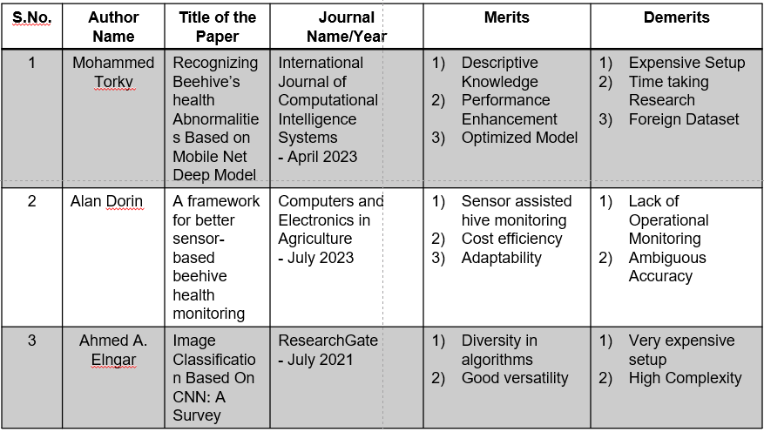

**CHALLENGES AND LIMITATIONS IN THE EXISTING SYSTEM**

* **Smart Beekeeping Monitoring system for beekeepers in India**
* Incorporates a live sensor designed to detect and monitor bee swarming activities in real-time and studies invasion of foreign species in beehive and enables beekeepers to proactively respond to swarming events and implement timely hive management strategies.
* Requires expensive hardware suite and constant monitoring for devices.
* **Design and Implementation of Sustainable Smart Beehive Monitoring**
* A simple theoretical study for Beehive Monitoring includes an examination of key aspects like bee behavior, hive dynamics, and the foundational principles behind the technology used in monitoring systems.
* This study is specific to Apic cerana Indica bee species only.

* **Monitoring Energy Efficiency in India through Energy Efficiency Indicators**
  + - Collaborative research work between government bodies is a dynamic process that involves the concerted efforts of multiple governmental agencies towards addressing shared challenges, advancing collective objectives, and fostering innovation.
    - Analyzing various aspects of flora and fauna diversity involves a comprehensive exploration of the intricate relationships, ecological dynamics, and conservation implications within ecosystems.
    - A comprehensive study into bee swarming activities involves an in-depth exploration of the intricate behaviors, environmental factors, and ecological significance associated with the phenomenon of bee swarms.

**SCOPE AND APPLICATION OF THE PROJECT**

* **Individual Bee Health Monitoring:** Provide beekeepers with a tool to assess the health of individual bees, enabling early detection of diseases and abnormalities. Individual Bee Health Monitoring represents a groundbreaking tool that empowers beekeepers with the capability to conduct real-time assessments of the well-being of individual bees within a colony.
* **Subspecies Identification:** Assisting beekeepers in identifying different subspecies plays a pivotal role in advancing targeted hive management and facilitating strategic breeding programs within the beekeeping industry. This specialized tool provides beekeepers with the means to distinguish between various subspecies of bees, allowing for a more nuanced and informed approach to hive management practices.
* **Optimized Hive Management:** Optimized Hive Management represents a crucial initiative aimed at enhancing the efficiency and productivity of commercial pollination services, especially within large-scale operations. This multifaceted approach integrates advanced technologies, data-driven insights, and best management practices to ensure the overall health and well-being of bee colonies involved in extensive pollination services..
* **Arduino Sensor Integration:** Integrate Arduino sensors to monitor live temperature and humidity conditions within beehives and establish a real-time data feed for continuous monitoring, allowing beekeepers to respond promptly to environmental changes and optimize hive conditions.
* **IoT Communication Protocols:** Implement efficient communication protocols for seamless data exchange between the image recognition system, Arduino sensors, and the web interface.

**PROPOSED ARCHITECTURE**

The proposed system for the project is an integrated web application that employs deep learning and real time interactivity.

1. **User Interface**: In the seamless and user-friendly interface, the process begins with the user uploading an image of the bee utilizing the Predict function. This intuitive feature not only simplifies the interaction but also serves as a key entry point for the system to initiate its sophisticated image recognition capabilities.
2. **Flask Module**: Flask Module routes the GET Request to the DL Module and returns the Pollen type, subspecies, health of the bee additionally it features a web page that on uploading the image of beehive predicts the status of beehive.
3. **DL Module**: This module represents a convergence of cutting-edge computer vision techniques and deep learning algorithms, harnessing the power of neural networks to unravel the rich details encapsulated within the image.
4. **H5 file:** The culmination of the system's analytical prowess results in the creation of an H5 file, where all the meticulously consolidated findings are systematically organized and stored.
5. **JSON Conversion:** The JSON format proves to be highly advantageous in this context due to its lightweight, human-readable, and easily interpretable nature. The conversion transforms the organized hierarchy of the H5 file into a structured JSON representation.
6. **Arduino Module:** Integrating a DHT11 sensor into the system introduces a live and dynamic dimension to temperature and humidity detection, enhancing the depth of environmental monitoring within the beehive.

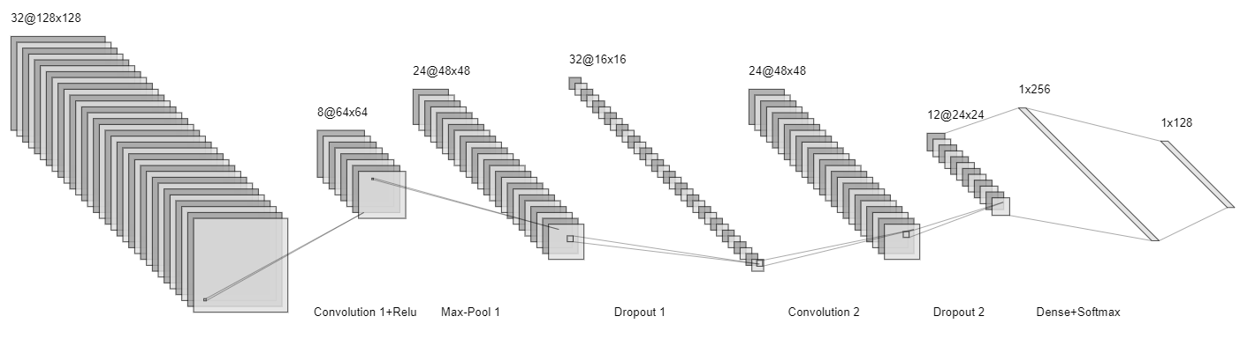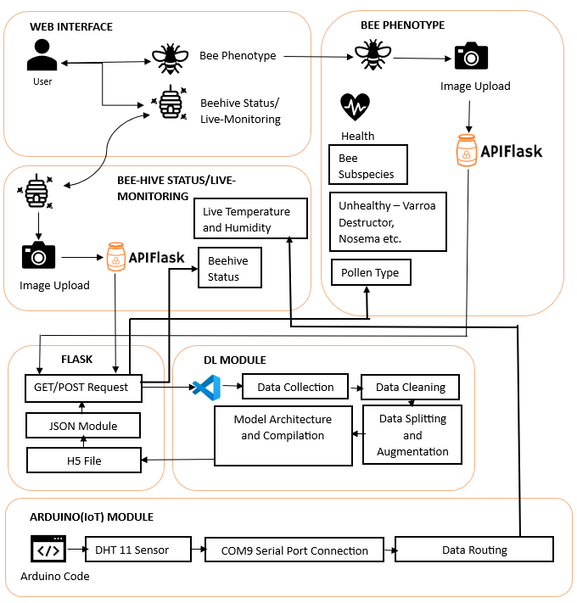

**PROPOSED MODULES**

* **Dashboard and User Interface Module:** This module, designed as the user interface for interacting with the system, offers a seamless and intuitive experience for users engaging in the process of uploading bee images and receiving predictions.
* **Image Upload and Inference Module:** This dedicated processing module plays a pivotal role in the system's workflow by efficiently handling user-uploaded bee images and facilitating the generation of new predictions.
* **Deep Learning Module:** This pivotal module is the intellectual core of the system, responsible for defining, training, and fine-tuning the deep learning model that underpins the classification of various attributes related to bees.
* **Bee attributes and Beehive Assessment Module**: This module defines the species, health, category of pollen of the uploaded bee images and assess the bee image using different attributes like contrast, normalization of values and various gray level transformations.
* **Arduino Sensor Module(IoT):** This module is used for live temperature and humidity conditions of the beehive. Integrating a DHT11 sensor into the system introduces a live and dynamic dimension to temperature and humidity detection, enhancing the depth of environmental monitoring within the beehive.
* **Flask Module:** Flask Module routes the GET Request to the DL Module and returns the Pollen type, subspecies, health of the bee additionally it features a web page that on uploading the image of beehive predicts the status of beehive.

**ALGORITHM DESCRIPTION**

1. **Mobile Net Deep Learning Model:-**

* MobileNet relies heavily on depthwise separable convolutions, which split the standard convolution into two separate operations: depthwise convolution and pointwise convolution.
* MobileNet architecture typically includes depthwise separable convolutions, inverted residuals, linear bottlenecks, global average pooling, fully connected layers, activation functions, normalization layers, and optional skip connections.

1. **Sequential Model:-**
   * The Sequential Model in Keras is a linear stack of layers, allowing for the easy construction of neural networks by adding one layer at a time in a sequential manner.
   * The Sequential Model is suitable for straightforward linear stack architectures, but it may not be sufficient for more complex models with multiple inputs or shared layers.
2. **Arduino DHT:-**

* DHT sensors come in various versions, such as DHT11, DHT21, and DHT22, and they can measure both humidity and temperature.
* The DHT library supports various DHT sensor models, including DHT11, DHT21, and DHT22. Different sensor models may have different levels of accuracy.

**UML DIAGRAMS**

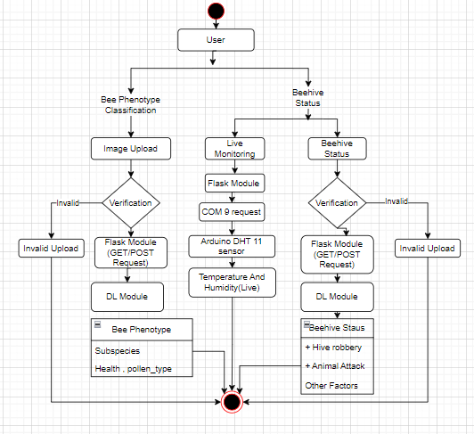

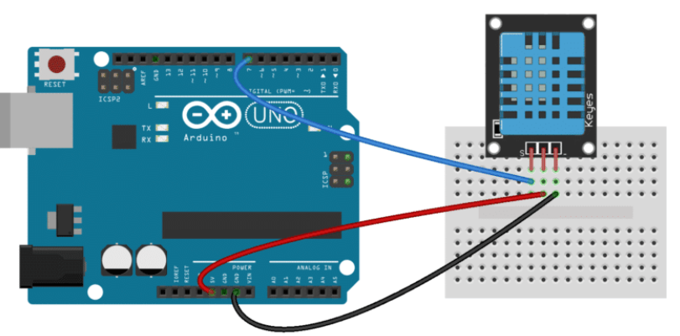

**DEMO**

#include "DHT.h"

#define DHTPIN 4// you can use

#define DHTTYPE DHT11//#define DHTTYPE DHT21

//#define DHTTYPE DHT22

DHT dht(DHTPIN, DHTTYPE);//you can also use pins 3, 4, 5, 12, 13 or 14

// Pin 15 can work but DHT must be disconnected during program upload

#include <LiquidCrystal_I2C.h>

LiquidCrystal_I2C lcd(0x27, 16, 2);

void setup() {

dht.begin();// initialize the sensor

lcd.backlight();// turn on lcd backlight

lcd.init();// initialize lcd

}

void loop() {

lcd.clear();

lcd.setCursor(0,0);// set the cursor on the first row and column

lcd.print("Humidity=");

lcd.print((float)dht.readHumidity());//print the humidity

lcd.print("%");

lcd.setCursor(0,1);//set the cursor on the second row and first column

lcd.print("Temp=");

lcd.print((float)dht.readTemperature());//print the temperature

lcd.print("Celsius");

delay(2000);

lcd.clear();

}

#include <dht.h>

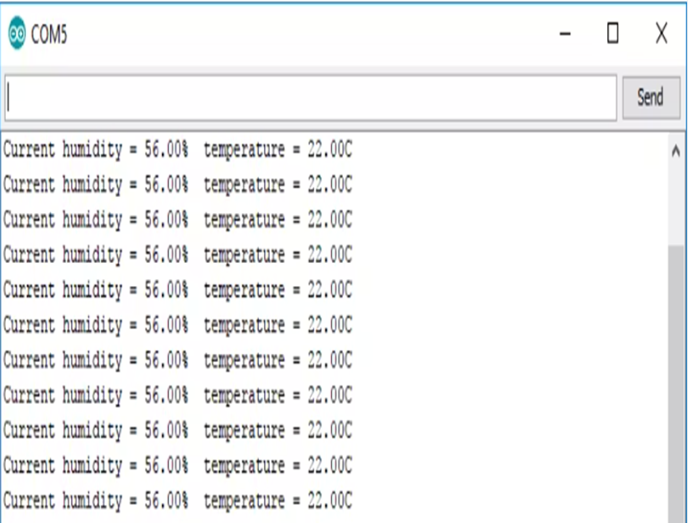dht DHT;

#define DHT11_PIN 7

void setup(){

Serial.begin(9600);

}

void loop(){

int chk = DHT.read11(DHT11_PIN);

Serial.print("Temperature = ");

Serial.println(DHT.temperature);

Serial.print("Humidity = ");

Serial.println(DHT.humidity);

delay(2000);

}

//Arduino Code

# Data augmentation

generator = ImageDataGenerator(

rotation_range=180,

zoom_range=0.1,

width_shift_range=0.2,

height_shift_range=0.2,

horizontal_flip=True,

vertical_flip=True

)

generator.fit(train_X)

earlystopper = EarlyStopping(monitor='val_accuracy', patience=25, verbose=1)

checkpointer = ModelCheckpoint('best.h5',

monitor='val_accuracy',

verbose=1,

save_best_only=True,

save_weights_only=True)

# Load MobileNet base model without top (fully connected) layers

base_model = MobileNet(input_shape=(img_width, img_height, 3), include_top=False, weights='imagenet')

# Freeze the layers of the base model

for layer in base_model.layers:

layer.trainable = False

# Create your own model on top of MobileNet

model = Sequential()

model.add(base_model)

model.add(GlobalAveragePooling2D())

model.add(Dense(128, activation='relu'))

model.add(Dropout(0.5))

model.add(Dense(train_y.columns.size, activation='softmax'))

**REFERENCES**

[1] Fei-Fei, L., Karppaathy, AL., Leung, T., Sharma, L., Sukthankar, R., & Loderici, G. (2021). IEEE Conference on Computer Vision Pattern Recognition Research(citation 80 time, HIC: 25 , CV: 110).

[2] M. Elissa., Laragatham, G., Sundaramoorthy, K., Mahheswari, K., Sajna, and Kumar, A., 2023, January. The Prediction Architecture Using ML. In 2023 International Conference on Artificial Intelligence and Knowledge Discovery in Concurrent Engineering (ICECONF) (pp. 1-6).IEEE.

[3] Jaayapraddha J. IEEE Conference on “Dissertation on hive wood types honey bee Apis Cerana Indica(Indian Honey Bee)” June 2022 pp 442-445

[4] Food and Agricultural Org. of the UN. (June 21, 2021). FAO—News Article: Bees Protection must for the Future of food security. Accessed: Oct 23,2023.[Online]. “Fine particles, thin anisotropy,” in Magnetism, vol. III, G. T. Rado and H. Suhl, Eds. New York: Academic, 2021, pp. 271–350.